Fire Fighter 6000 hours OJT (3 Years)
WSFF JATC Apprentice

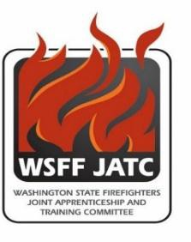
Hours Credits

A. IFSAC or Pro board Firefighter I & II Recruit School | 630 | 27
B. Hazmat Operations | 30 | 2

C. Emergency Medical Technician 200
D. Fire Protection Strategy & Tactics | 50 | 5
E. Fire Protection Systems | 50 | 5
F. Fire Protection Hydraulics | 50 | 5
G. Building Construction | 50 | 5
H. Fire Protection Codes/Inspections | 50 | 5

-

Total: 1110 54

Fire Officer 4000 OJT Hours (2 Years) Hours Credits

A. English Composition | 50 | 5
B. Applied Business Math | 50 | 5
C. Interpersonal Communication | 50 | 5
D. Building Construction | 50 | 5
E. Fire Service Instructor | 40 | 4
F. Fire Service Incident Safety Officer | 30 | 3
G. Fire Officer I | 50 | 5
H. Fire Officer II | 50 | 5
Total: | 370 | 37
Fire Apparatus Driver/Operator 2000 OJT hours (1 Year) | Hours | Credits
A. Fire Protection Hydraulics | 50 | 5
B. Emergency Vehicle Incident Prevention Training | 16
C. Pump Operators Academy | 40
D. Fire Apparatus Equipment | 60
Total: | 166

